**Step 1**: Login to Browser Using IP 192.168.1.1

**Step 2**: Enter user name : admin

Password: admin

After Login in will ask for Password change You can configure a new password!

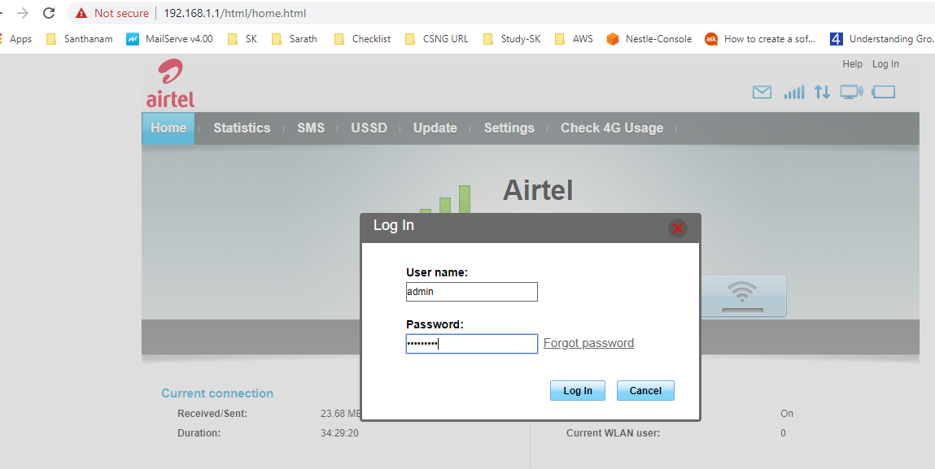

**In Next Window Do the Following Process**

**Step 3**: Select Settings

**Step 4**: Select WLAN under WLAN tab Select DHCP tab.

**Step 5**: In DHCP tab enter 0.1 in IP address Field .

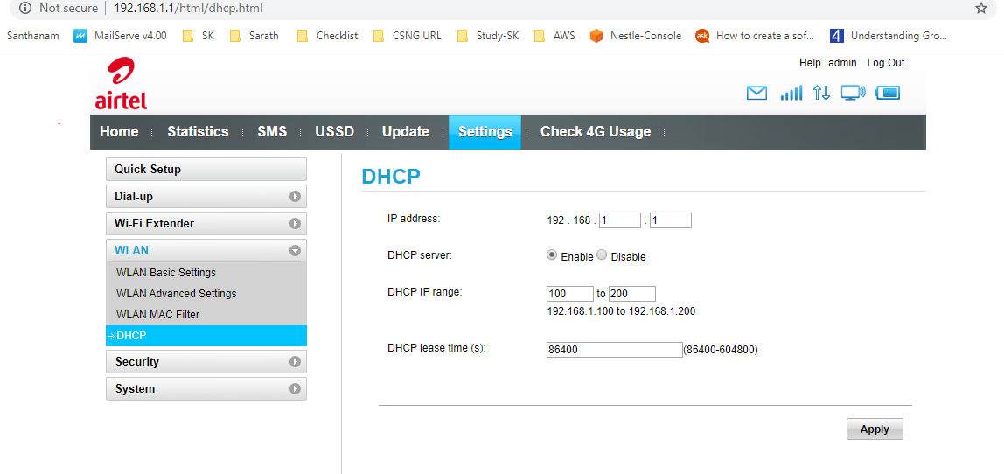

**Step 6**: After changing it will ask for a Restart click oK

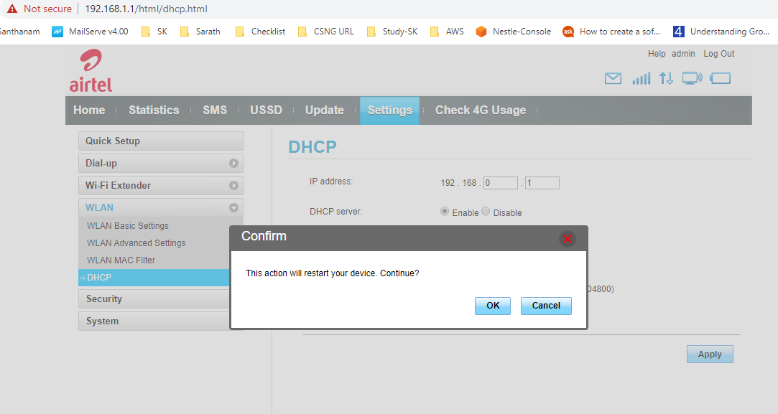

**Step 7**: Login again using IP 192.168.0.1

